Titel:
Purpose:
Status: Review ☐ Approved ☐
Date:
Start time (UTC):
End time (UTC):
Max Altitude (AGL): Feet AGL
Pilot Name:
Pilot Contact Number:
Observer mobile phone number:
Aircraft Registration Number (Call sign):
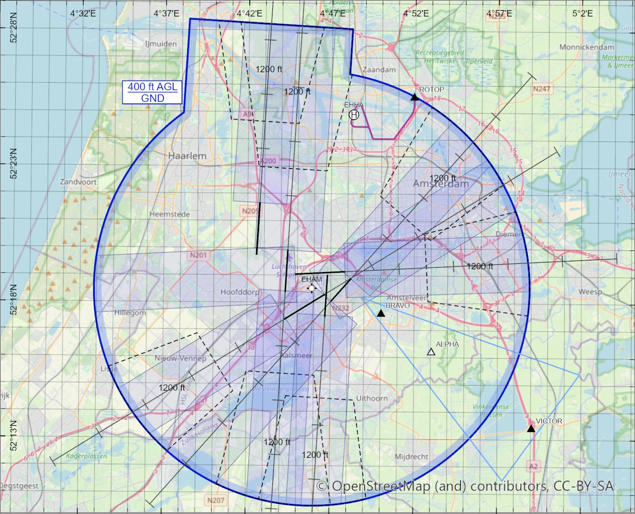
Organisation name:
Organisation email:
Organisation tel. nr:
Operational Authorisation Number:
STS/CBO/LUC number:
Aircraft Serial Number:
Procedure
- Complete the information above and email this form at least 24 hours before start of the drone flight to droneplanning@lvnl.nl. Keep drone planning informed about any changes.
- The drone planner will review your request and inform you by email.
- Coordination with ATC will be at least 1 hour before the flight.
- After approval contact ATC via Delivery for departure clearance.

